How to Install Nginx and PHP 7.3 on Debian 10
July 20, 2019 3 min read
7,422

author:
David

How to Install Nginx and PHP 7.3 on Debian 10
Just recently on July 6th, 2019, Debian 10 buster released, and with it came a lot of features. This tutorial will show you how you can install Nginx mainline version on Debian 10 for optimal performance.

Step 1: Install Nginx
Firstly we need to install the prerequisites.
sudo apt install curl gnupg2 ca-certificates lsb-release
Then we need to add the Nginx mainline package to our repository so that when we run apt install nginx, we will download the mainline version instead of the old stable version.
echo "deb http://nginx.org/packages/mainline/debian `lsb_release -cs` nginx" \
| sudo tee /etc/apt/sources.list.d/nginx.list
Optionally, if you would rather want to use the older and slower stable version of Nginx you can do so by running: (Remember that you should only run one of the following)
echo "deb http://nginx.org/packages/mainline/debian `lsb_release -cs` nginx" \
| sudo tee /etc/apt/sources.list.d/nginx.list
Next we need to download the signing key so that we can verify its authenticity
curl -fsSL https://nginx.org/keys/nginx_signing.key | sudo apt-key add -
If it prints out OK! then you are good to go!
Now that we have downloaded & verified its authnicity lets install it!
sudo apt update
sudo apt install nginx
That’s it! You have now installed the latest release of Nginx on Debian 10. You should now start it!
sudo systemctl start nginx.service
Don’t forget to make it automaticly start on system boot as well.
sudo systemctl enable nginx.service
Visit your server’s IP address in your webbrowser. You should now see something along these lines if it is working correctly.
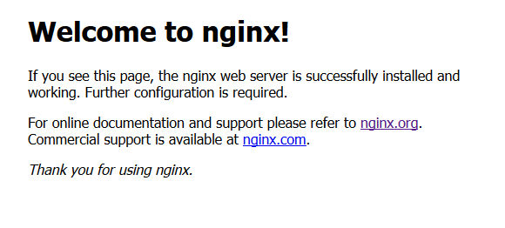

Step 2: Install PHP 7.3
To add the repositories for PHP:
sudo apt-get install software-properties-common
Run this to download your added repositories:
sudo apt update
We can now install PHP now that we have all of the required repositories.
sudo apt install php7.3-fpm php7.3-common php7.3-mysql php7.3-gmp php7.3-curl php7.3-intl php7.3-mbstring php7.3-xmlrpc php7.3-gd php7.3-xml php7.3-cli php7.3-zip php7.3-soap php7.3-imap
It is recommended to raise the memory limit to improve the overall performance. Your PHP configuration is located in/etc/php/7.3/fpm/php.ini.
sudo nano /etc/php/7.3/fpm/php.ini
Press + and search for memory_limit.
Replace it with memory_limit = 256
Save & exit by pressing + followed by

Step 3: Configure Nginx
Add nginx to www-data group
sudo usermod -a -G www-data nginx
Change owner of directory to www-data
sudo chown -R www-data /usr/share/nginx/html
Go into your default.conf file
sudo nano /etc/nginx/conf.d/default.conf
Replace your existing configuration file with the one below
server {
listen 80;
server_name localhost;

root /usr/share/nginx/html;
index index.php index.html index.htm;

location / {
if ($request_uri ~ ^/(.*)\.html$) {
return 302 /$1;
}
}

error_page 500 502 503 504 /50x.html;
location = /50x.html {
root /usr/share/nginx/html;
}
location ~ \.php$ {
fastcgi_split_path_info ^(.+\.php)(/.+)$;
fastcgi_pass unix:/var/run/php/php7.3-fpm.sock;
fastcgi_index index.php;
fastcgi_param SCRIPT_FILENAME $document_root$fastcgi_script_name;
include fastcgi_params;
}

}
Save & exit by pressing + followed by
Now restart your Nginx:
service nginx restart
That’s it! However, you may now test to see if php works
nano /usr/share/nginx/html/phpinfo.php
Add the following lines
<?php

phpinfo();

?>
Save & exit by pressing + followed by
Now go to YOURSERVERIP/phpinfo.php in your web browser. You should see something along these lines
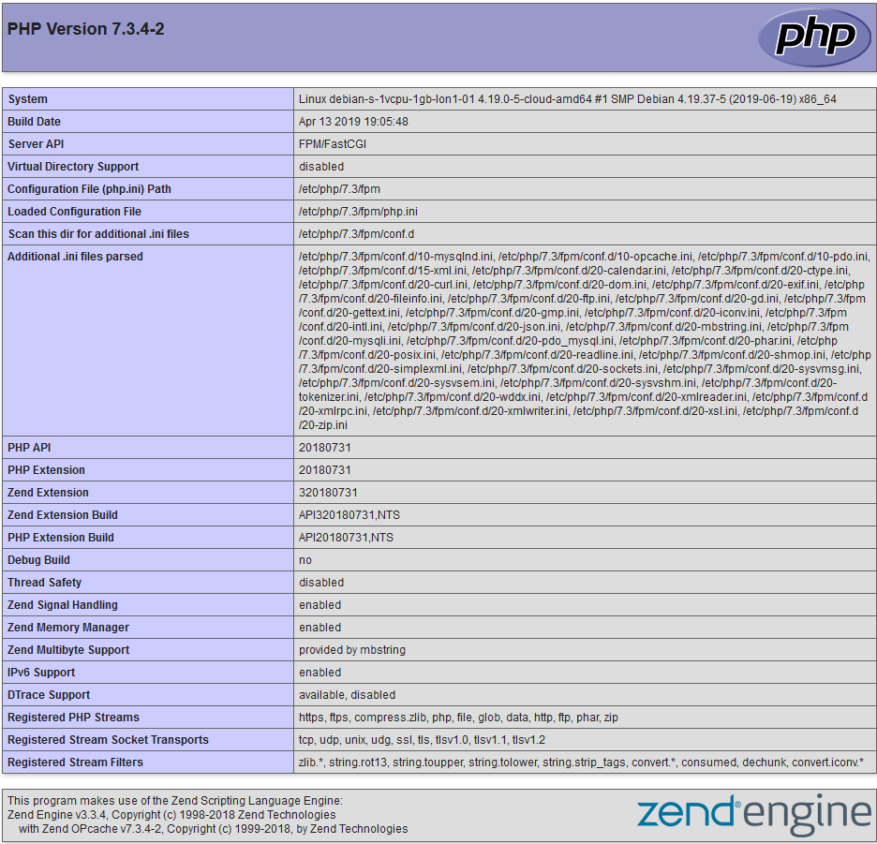
That’s it! Now you know how to install Nginx and PHP 7.3 on Debian 10. You can now go ahead and install anything you want, such as WordPress. Don’t forget to try out our VPS too! Our servers are located in stockholm, so if you’re from Sweden feel free to check out our Swedish site too, and grab yourself a Stockholm VPS.
https://hostup.org/blog/how-to-install-nginx-and-php-7-3-on-debian-10/

How To Install Linux, Nginx, MariaDB, PHP (LEMP stack) on Debian 10
NginxLEMPDebian 10
- 

- By Brian Boucheron and Erika Heidi
Last Validated onMarch 30, 2020 Originally Published onJuly 10, 2019 76.8k views

Not using Debian 10?
Choose a different version or distribution.

Introduction
The LEMP software stack is a group of software that can be used to serve dynamic web pages and web applications. The name “LEMP” is an acronym that describes a Linux operating system, with an (E)Nginx web server. The backend data is stored in a MariaDB database and the dynamic processing is handled by PHP.
Although this software stack typically includes MySQL as the database management system, some Linux distributions — including Debian — use MariaDB as a drop-in replacement for MySQL.
In this guide, you’ll install a LEMP stack on a Debian 10 server using MariaDB as the database management system.

Prerequisites
To complete this guide, you will need access to a Debian 10 server. This server should have a regular user configured with sudo privileges and a firewall enabled with ufw. To set this up, you can follow our Initial Server Setup with Debian 10 guide.

Step 1 — Installing the Nginx Web Server
In order to serve web pages to your site visitors, we are going to employ Nginx, a popular web server which is well known for its overall performance and stability.
All of the software you will be using for this procedure will come directly from Debian’s default package repositories. This means you can use the apt package management suite to complete the installation.
Since this is the first time you’ll be using apt for this session, you should start off by updating your local package index. You can then install the server:
sudo apt update
sudo apt install nginx

On Debian 10, Nginx is configured to start running upon installation.
If you have the ufw firewall running, you will need to allow connections to Nginx. You should enable the most restrictive profile that will still allow the traffic you want. Since you haven’t configured SSL for your server yet, for now you only need to allow HTTP traffic on port 80.
You can enable this by typing:
sudo ufw allow 'Nginx HTTP'

You can verify the change by typing:
sudo ufw status

You should see HTTP traffic allowed in the displayed output:
Output
Status: active

To Action From
-- ------ ----
OpenSSH ALLOW Anywhere
Nginx HTTP ALLOW Anywhere
OpenSSH (v6) ALLOW Anywhere (v6)
Nginx HTTP (v6) ALLOW Anywhere (v6)
Now, test if the server is up and running by accessing your server’s domain name or public IP address in your web browser. If you do not have a domain name pointed at your server and you do not know your server’s public IP address, you can find it by typing one of the following into your terminal:
ip addr show eth0 | grep inet | awk '{ print $2; }' | sed 's/\/.*$//'

This will print out a few IP addresses. You can try each of them in turn in your web browser.
Type one of the addresses that you receive in your web browser. It should take you to Nginx’s default landing page:
http://your_domain_or_IP

If you see the above page, you have successfully installed Nginx.

Step 2 — Installing MariaDB
Now that you have a web server up and running, you need to install the database system to be able to store and manage data for your site.
In Debian 10, the metapackage mysql-server, which was traditionally used to install the MySQL server, was replaced by default-mysql-server. This metapackage references MariaDB, a community fork of the original MySQL server by Oracle, and it’s currently the default MySQL-compatible database server available on debian-based package manager repositories.
For longer term compatibility, however, it’s recommended that instead of using the metapackage you install MariaDB using the program’s actual package, mariadb-server.
To install this software, run:
sudo apt install mariadb-server

When the installation is finished, it’s recommended that you run a security script that comes pre-installed with MariaDB. This script will remove some insecure default settings and lock down access to your database system. Start the interactive script by running:
sudo mysql_secure_installation

This script will take you through a series of prompts where you can make some changes to your MariaDB setup. The first prompt will ask you to enter the current database root password. This is not to be confused with the system root. The database root user is an administrative user with full privileges over the database system. Because you just installed MariaDB and haven’t made any configuration changes yet, this password will be blank, so just press ENTER at the prompt.
The next prompt asks you whether you’d like to set up a database root password. Because MariaDB uses a special authentication method for the root user that is typically safer than using a password, you don’t need to set this now. Type N and then press ENTER.
From there, you can press Y and then ENTER to accept the defaults for all the subsequent questions. This will remove anonymous users and the test database, disable remote root login, and load these new rules so that MariaDB immediately respects the changes you have made.
When you’re finished, log in to the MariaDB console by typing:
sudo mariadb

This will connect to the MariaDB server as the administrative database user root, which is inferred by the use of sudo when running this command. You should see output like this:
Output
Welcome to the MariaDB monitor. Commands end with ; or \g.
Your MariaDB connection id is 74
Server version: 10.3.15-MariaDB-1 Debian 10

Copyright (c) 2000, 2018, Oracle, MariaDB Corporation Ab and others.

Type 'help;' or '\h' for help. Type '\c' to clear the current input statement.

MariaDB [(none)]>
Notice that you didn’t need to provide a password to connect as the root user. That works because the default authentication method for the administrative MariaDB user is unix_socket instead of password. Even though this might look like a security concern at first, it makes the database server more secure because the only users allowed to log in as the root MariaDB user are the system users with sudo privileges connecting from the console or through an application running with the same privileges. In practical terms, that means you won’t be able to use the administrative database root user to connect from your PHP application.
For increased security, it’s best to have dedicated user accounts with less expansive privileges set up for every database, especially if you plan on having multiple databases hosted on your server. To demonstrate such a setup, we’ll create a database named example_database and a user named example_user, but you can replace these names with different values.
To create a new database, run the following command from your MariaDB console:
CREATE DATABASE example_database;

Now you can create a new user and grant them full privileges on the custom database you’ve just created. The following command defines this user’s password as password, but you should replace this value with a secure password of your own choosing.
GRANT ALL ON example_database.* TO 'example_user'@'localhost' IDENTIFIED BY 'password' WITH GRANT OPTION;

This will give the example_user user full privileges over the example_database database, while preventing this user from creating or modifying other databases on your server.
Flush the privileges to ensure that they are saved and available in the current session:
FLUSH PRIVILEGES;

Following this, exit the MariaDB shell:
exit

You can test if the new user has the proper permissions by logging in to the MariaDB console again, this time using the custom user credentials:
mariadb -u example_user -p

Note the -p flag in this command, which will prompt you for the password used when creating the example_user user. After logging in to the MariaDB console, confirm that you have access to the example_database database:
SHOW DATABASES;

This will give you the following output:
Output
+--------------------+
| Database |
+--------------------+
| example_database |
| information_schema |
+--------------------+
2 rows in set (0.000 sec)
To exit the MariaDB shell, type:
exit

At this point, your database system is set up and you can move on to installing PHP, the final component of the LEMP stack.

Step 3 — Installing PHP for Processing
You have Nginx installed to serve your content and MySQL installed to store and manage your data. Now you can install PHP to process code and generate dynamic content for the web server.
While Apache embeds the PHP interpreter in each request, Nginx requires an external program to handle PHP processing and act as bridge between the PHP interpreter itself and the web server. This allows for a better overall performance in most PHP-based websites, but it requires additional configuration. You’ll need to install php-fpm, which stands for “PHP fastCGI process manager”, and tell Nginx to pass PHP requests to this software for processing. Additionally, you’ll need php-mysql, a PHP module that allows PHP to communicate with MySQL-based databases. Core PHP packages will automatically be installed as dependencies.
To install the php-fpm and php-mysql packages, run:
sudo apt install php-fpm php-mysql

You now have your PHP components installed. Next, you’ll configure Nginx to use them.

Step 4 — Configuring Nginx to Use the PHP Processor
When using the Nginx web server, server blocks (similar to virtual hosts in Apache) can be used to encapsulate configuration details and host more than one domain on a single server. In this guide, we’ll use your_domain as example domain name. To learn more about setting up a domain name with DigitalOcean, see our introduction to DigitalOcean DNS.
On Debian 10, Nginx has one server block enabled by default and is configured to serve documents out of a directory at /var/www/html. While this works well for a single site, it can become difficult to manage if you are hosting multiple sites. Instead of modifying /var/www/html, let’s create a directory structure within /var/www for the your_domain website, leaving /var/www/html in place as the default directory to be served if a client request doesn’t match any other sites.
Create the root web directory for your_domain as follows:
sudo mkdir /var/www/your_domain

Next, assign ownership of the directory with the $USER environment variable, which should reference your current system user:
sudo chown -R $USER:$USER /var/www/your_domain

Then, open a new configuration file in Nginx’s sites-available directory using your preferred command-line editor. Here, we’ll use nano:
sudo nano /etc/nginx/sites-available/your_domain

This will create a new blank file. Paste in the following bare-bones configuration:
/etc/nginx/sites-available/your_domain
server {
listen 80;
listen [::]:80;

root /var/www/your_domain;
index index.php index.html index.htm;

server_name your_domain;

location / {
try_files $uri $uri/ =404;
}

location ~ \.php$ {
include snippets/fastcgi-php.conf;
fastcgi_pass unix:/var/run/php/php7.3-fpm.sock;
}
}

This is a basic configuration that listens on port 80 and serves files from the web root you just created. It will only respond to requests to the host or IP address provided after server_name, and any files ending in .php will be processed by php-fpm before Nginx sends the results to the user.
Note: If you are running a PHP version different from PHP 7.3, you would need to adjust the fastcgi_pass to match the PHP version that you are using.
When you’re done editing, save and close the file. If you used nano to create the file, do so by typing CTRL+X and then y and ENTER to confirm.
Activate your configuration by linking to the config file from Nginx’s sites-enabled directory:
sudo ln -s /etc/nginx/sites-available/your_domain /etc/nginx/sites-enabled/

This will tell Nginx to use the configuration next time it is reloaded. You can test your configuration for syntax errors by typing:
sudo nginx -t

If any errors are reported, go back to your configuration file to review its contents before continuing.
When you are ready, reload Nginx to make the changes:
sudo systemctl reload nginx

Next, you’ll create a file in your new web root directory to test out PHP processing.

Step 5 — Creating a PHP File to Test Configuration
Your LEMP stack should now be completely set up. You can test it to validate that Nginx can correctly hand .php files off to your PHP processor.
You can do this by creating a test PHP file in your document root. Open a new file called info.php within your document root in your text editor:
nano /var/www/your_domain/info.php

Type or paste the following lines into the new file. This is valid PHP code that will return information about your server:
/var/www/your_domain/info.php
<?php
phpinfo();
?>

When you are finished, save and close the file by typing CTRL+X and then y and ENTER to confirm.
You can now access this page in your web browser by visiting the domain name or public IP address you’ve set up in your Nginx configuration file, followed by /info.php:
http://your_domain/info.php
You will see a web page containing detailed information about your server:

After checking the relevant information about your PHP server through that page, it’s best to remove the file you created as it contains sensitive information about your PHP environment and your Debian server. You can use rm to remove that file:
rm /var/www/your_domain/info.php

You can always regenerate this file if you need it later. Next, we’ll test the database connection from the PHP side.

Step 6 — Testing Database Connection from PHP (Optional)
If you want to test if PHP is able to connect to MariaDB and execute database queries, you can create a test table with dummy data and query for its contents from a PHP script.
First, connect to the MariaDB console with the database user you created in Step 2 of this guide:
mariadb -u example_user -p

Create a table named todo_list. From the MariaDB console, run the following statement:
CREATE TABLE example_database.todo_list (
item_id INT AUTO_INCREMENT,
content VARCHAR(255),
PRIMARY KEY(item_id)
);
Now, insert a few rows of content in the test table. You might want to repeat the next command a few times, using different values:
INSERT INTO example_database.todo_list (content) VALUES ("My first important item");

To confirm that the data was successfully saved to your table, run:
SELECT * FROM example_database.todo_list;

You will see the following output:
Output
+---------+--------------------------+
| item_id | content |
+---------+--------------------------+
| 1 | My first important item |
| 2 | My second important item |
| 3 | My third important item |
| 4 | and this one more thing |
+---------+--------------------------+
4 rows in set (0.000 sec)

After confirming that you have valid data in your test table, you can exit the MariaDB console:
exit

Now you can create the PHP script that will connect to MariaDB and query for your content. Create a new PHP file in your custom web root directory using your preferred editor. We’ll use nano for that:
nano /var/www/your_domain/todo_list.php

Add the following content to your PHP script:
<?php
$user = "example_user";
$password = "password";
$database = "example_database";
$table = "todo_list";

try {
$db = new PDO("mysql:host=localhost;dbname=$database", $user, $password);
echo "<h2>TODO</h2><ol>";
foreach($db->query("SELECT content FROM $table") as $row) {
echo "<li>" . $row['content'] . "</li>";
}
echo "</ol>";
} catch (PDOException $e) {
print "Error!: " . $e->getMessage() . "<br/>";
die();
}

Save and close the file when you’re done editing.
You can now access this page in your web browser by visiting the domain name or public IP address you’ve set up in your Nginx configuration file, followed by /todo_list.php:
http://your_domain/todo_list.php
You should see a page like this, showing the content you’ve inserted in your test table:

That means your PHP environment is ready to connect and interact with your MariaDB server.

Conclusion
In this guide, you’ve built a flexible foundation for serving PHP websites and applications to your visitors, using Nginx as web server. You’ve set up Nginx to handle PHP requests through php-fpm, and you also set up a MariaDB database to store your website’s data.
To further improve your current setup, you can install Composer for dependency and package management in PHP, and you can also install an OpenSSL certificate for your website using Let’s Encrypt.
https://www.digitalocean.com/community/tutorials/how-to-install-linux-nginx-mariadb-php-lemp-stack-on-debian-10

How to Install Nginx with PHP-FPM on Debian 10
Written by Rahul, Updated on December 4, 2019
The FastCGI Process Manager (FPM) is an alternative to the FastCGI configuration with multiple enhancements. This is useful for high load websites. This tutorial will help you with the installation and configuration of PHP-FPM with Nginx on your Debian 10 Buster Linux system.

Prerequsities
You must have SSH access to the Debian 10 system with Sudo privileges.

Nginx Installation
Nginx packages are available under default repositories. SSH to your Debian 10 system with sudo privileges accounts and install the Nginx web server from the official repository.
sudo apt update
sudo apt install nginx

PHP Installation
For the PHP installation we recommend to use Ondřej Surý‘s PPA, which provides latest PHP versions for Debian systems. Use the below couple of commands to add the PPA to your system.
wget -q https://packages.sury.org/php/apt.gpg -O- | sudo apt-key add -
sudo echo "deb https://packages.sury.org/php/ buster main" | tee /etc/apt/sources.list.d/php.list
Then install PHP latest version available on the day of writing this tutorial. Simply execute follows commands for the installation of PHP and PHP-FPM packages.
apt update
sudo apt install php php-fpm
Note:- When you are using PHP-FPM. All the PHP modules configurations are residing under /etc/php/7.3/fpm/ directory. You can read more about enable/disable PHP modules.
After installing the above packages php7.3-fpm service will automatically be started. You can make sure by typing below command on terminal.
sudo systemctl status php7.3-fpm

● php7.3-fpm.service - The PHP 7.3 FastCGI Process Manager
Loaded: loaded (/lib/systemd/system/php7.3-fpm.service; enabled; vendor preset: enabled)
Active: active (running) since Tue 2019-12-03 10:01:54 UTC; 24min ago
Docs: man:php-fpm7.3(8)
Main PID: 9883 (php-fpm7.3)
Status: "Processes active: 0, idle: 2, Requests: 3, slow: 0, Traffic: 0req/sec"
Tasks: 3 (limit: 3587)
Memory: 14.2M
CGroup: /system.slice/php7.3-fpm.service
├─9883 php-fpm: master process (/etc/php/7.3/fpm/php-fpm.conf)
├─9884 php-fpm: pool www
└─9885 php-fpm: pool www

Dec 03 10:01:54 tecadmin-debian10 systemd[1]: Starting The PHP 7.3 FastCGI Process Manager...
Dec 03 10:01:54 tecadmin-debian10 systemd[1]: Started The PHP 7.3 FastCGI Process Manager.

Nginx Configuration
Let’s create Nginx virtual host to run with FPM/FastCGI. For this tutorial, we use default VirtualHost. Edit VirtualHost host configuration file in a text editor. You can create new VirtualHost as per your requirements, so make sure to enable any new VirtualHost.
sudo vim /etc/nginx/sites-available/example.com
Use the below basic Nginx Virtual host configuration with PHP FPM settings. Update the configuration as followings.
server { listen 80; root /var/www/html; index index.php index.html index.htm; server_name example.com; location / { try_files $uri $uri/ =404; } location ~ \.php$ { include snippets/fastcgi-php.conf; fastcgi_pass unix:/run/php/php7.3-fpm.sock; } }
1  2  3  4  5  6  7  8  9  10  11  12  13  14  15 | server {  listen 80;  root /var/www/html;  index index.php index.html index.htm;  server_name example.com;  location / {  try_files $uri $uri/ =404;  }  location ~ \.php$ {  include snippets/fastcgi-php.conf;  fastcgi_pass unix:/run/php/php7.3-fpm.sock;  }  }

Save your changes to the configuration file and create a link to site enabled directory.
sudo ln -s /etc/nginx/sites-available/example.com /etc/nginx/sites-enabled/example.com
Then restart Nginx service to reload the changes.
sudo systemctl restart nginx.service

Test Setup
Create a PHP script with phpinfo() function and place it to your server document root. Use below command to do it.
echo "<?php phpinfo(); ?>" > /var/www/html/info.php
Now access the info.php using server IP address (for default VirtualHost) for your configured domain in Nginx VirtualHost.
http://localhost/info.php
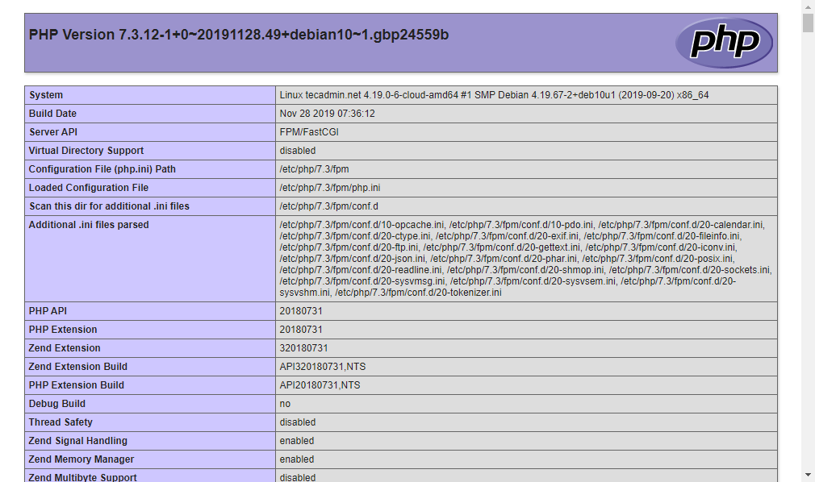

Conclusion
All done. You have successfully configured Nginx web server with PHP-FPM on your Debian 10 (Buster) Linux. Your server is ready to host websites.
https://tecadmin.net/install-nginx-php-fpm-debian-10/

